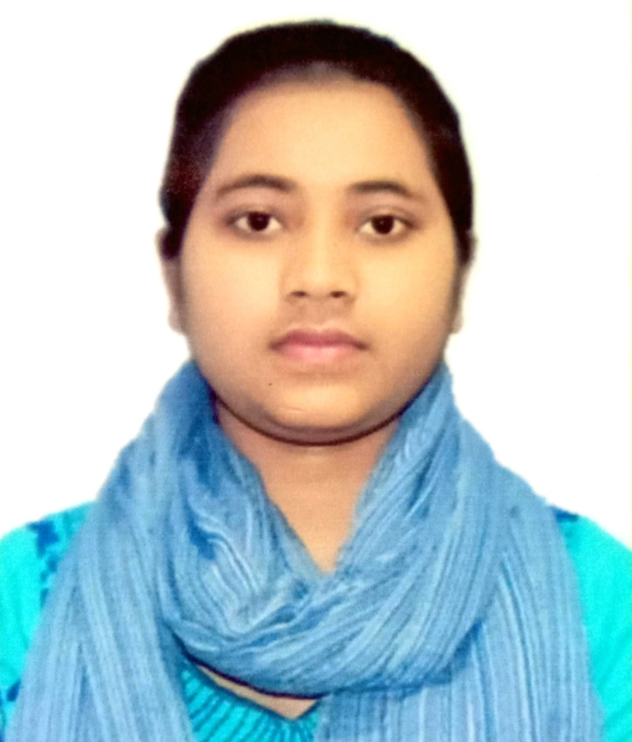 |  |  | MArufa Akter  Experience  General member • UIU Computer Club  Skill  - C  - C++  - JAVA  Education  UNITED INTERNATIONAL UNIVERSITY, UNITED CITY, DHAKA  - BACHELOR OF SCIENCE IN COMPUTER SCIENCE AND ENGINEERING, (5th trimester Running, 2024)  - Major: Computer Science and Engineering  GURUDAYAL GOVERNMENT COLLEGE, KISHOREGANJ  - HIGHER SECONDARY SCHOOL CERTIFICATE, (2020)  - Group: Science  - Result: GPA 5.00 Out of 5.00  JARAITALA HIGH SCHOOL AND COLLEGE, KISHOERGANJ  - SECONDARY SCHOOL CERTIFICATE, (2018)  - Group: Science  - Result: GPA 5.00 Out of 5.00  PERSONAL INFORMATION  Father’s Name: Mongol Mia  Mother’s Name: Nasima  Date of Birth: 19 September, 2001  Marital Status: Married  Religion: Islam  Permanent Address: Village- Shajanpur, Post- Jaraitala, Nikli, Kishoreganj  References  Available upon request.
 | United City, Madani Avenue, Dhaka-1212
 | 01308510297
 | makter223230@bscse.uiu.ac.bd
 | linkedin.com/in/marufa-akter-27684a2b2

Objective
I am a student.

